EdPlan/EasyIEP How To: Change My Password
1. Log into EdPlan/EasyIEP
2. Select My Account on the green menu bar.

3. New window opens. Enter current password.
4. Enter new password: at least 6 letters (at least one letter is capitalized), 1 symbol, 1 number
5. Update the database
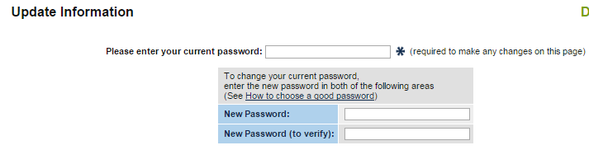

6. Other information will appear in the window. Do no change information in this section. Contact SRESD Central Records.
Or
1. Contact the SRESD Central Records Department

