1. Log into EdPlan
2. View Caseload
3. Select Student
4. IEP Process – Select Section 4: Goals and Objectives
Bottom of page 3 choices are offered: Select Add Goals from BANK
#4
5. New window opens. Goal banks are set up per case manager. In the snapshot below, the case manager has no goals in the bank.
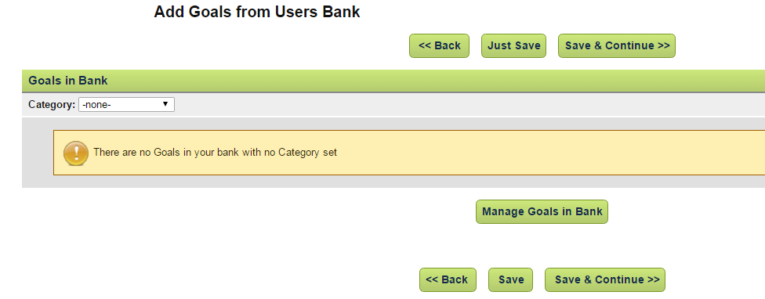
#6
6. Choose MANAGE GOALS IN BANK.
7. New window opens. See snapshot below.
8. Case managers may add text to create custom goals. See snapshot below. Goal #1.
9. Case managers may Add Goals from “lists” to the Goal Bank. Additional information Step #15.
10. Case managers may IMPORT Goals into the Goal Bank from their caseload. When a case manager chooses this option, all goals from each students on their caseload will be imported to the bank. The goals will import with the following information: dates, student’s name, data and data tools. The goals imported will need modifications when choosing the goal for another student’s IEP. The goal will import without compliance checks for measurability. It is the case manager’s responsibility to modify the goal to meet the student’s needs and compliance standards. Please refer to #19 for additional information.
11. The case manager may elect to set up categories, for example, basic reading, reading comprehension, written expression, behavior, speech articulation, and so on. Goals can be organized to best meet the case manager’s needs. Go to Step #20 for additional assistance in setting up categories.
12. Save or Save and Continue.
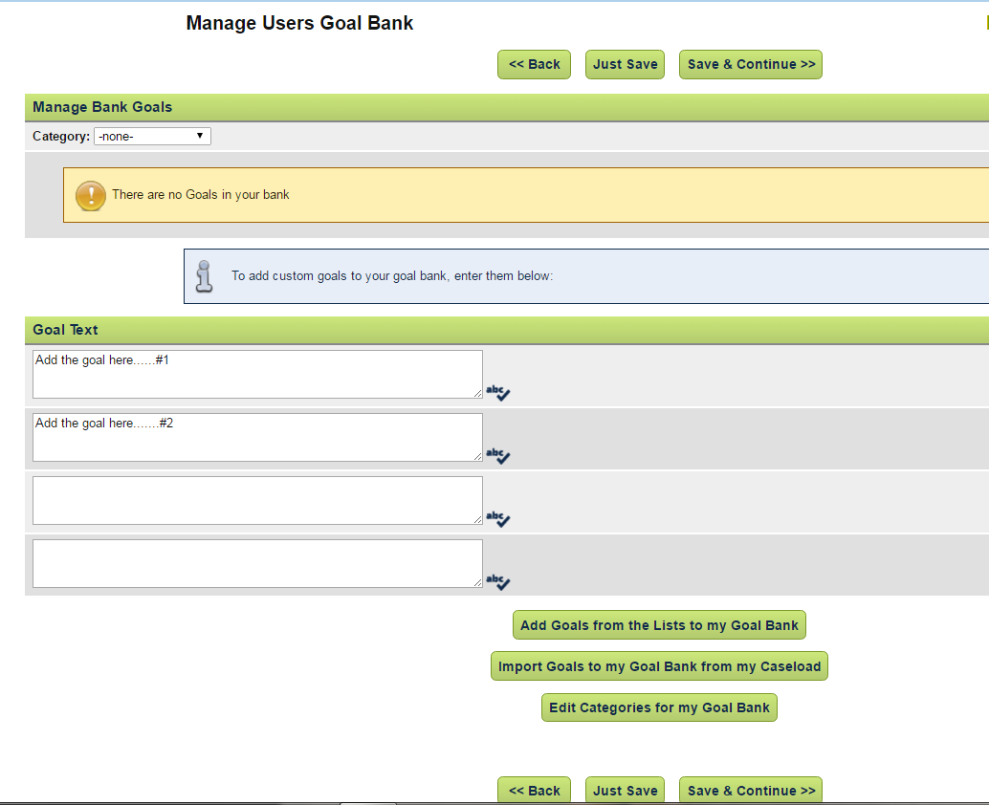
#12
#9
#11
#10
#8
#7

13. After a SAVE or SAVE AND CONTINUE is selected. A new window opens. Select and check a goal(s) to be included in the IEP. Select Save or Save and Continue. See snapshot below.
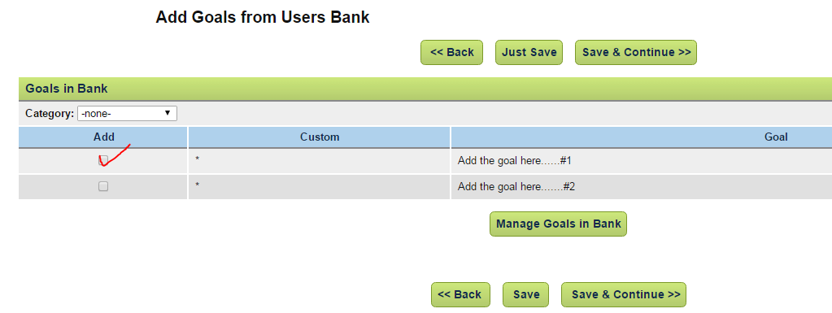
#13
14. After the goal has been selected, the case manager will be redirected to the IEP. Goal #1 appears in the IEP.
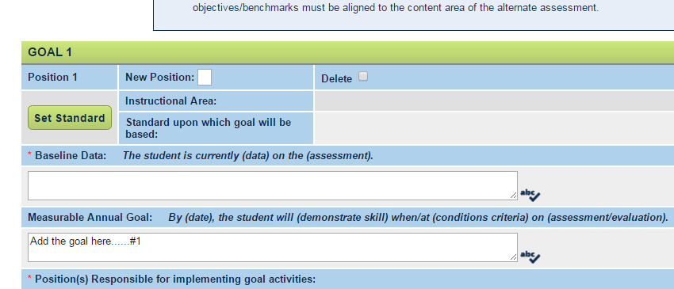
#14

ADDING GOALS FROM A LIST
15. Select Add Goal(s) from List.
16. A new window opens. A compliant goal framework is immediately available. Check the box to use this basic framework and select Save and Continue. This will take the user to the IEP with a new goal available for additional information.
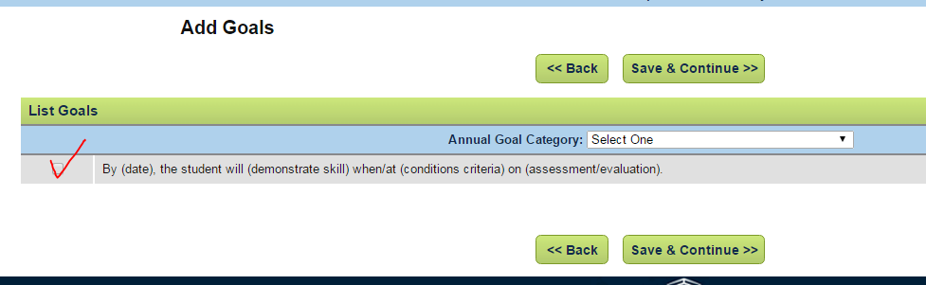
17. There are goals available from categories in the dropdown menu. See snapshot. Select Category.
18. If written expression is chosen as a category, a new window opens with goals developed for written expression. See snapshot. Just because goals are listed in the category, the user is still responsible to ensure the goal: meets the student’s needs and meets the requirements for a compliant goal. Select Save and Continue to place the selected goal into the IEP.
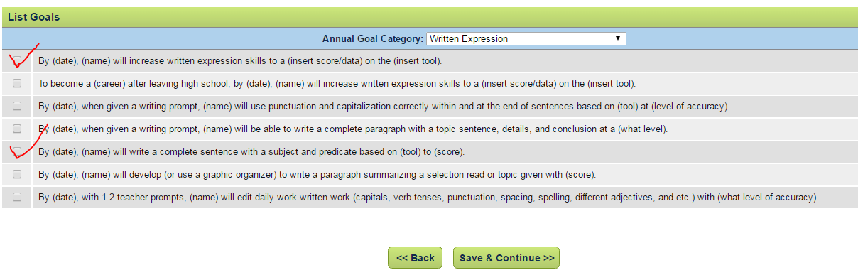

19. Another way to access the goal bank without importing the goals into a student’s IEP is as follows:
a. Refer to green menu bar. MY ACCOUNT.
#19 a
b. A drop down menu will appear. Choose MY GOAL BANK.
#19 b
c. New window opens. Manage Annual Goal Bank. See snapshot below. Notice that goals can be placed into positions, deleted, modified, added to categories, and additional goals can be added to the database.
Users should always update the database upon completion. These goal will not automatically enter a student’s IEP as no student file was opened prior to working on the goal bank, in this example.
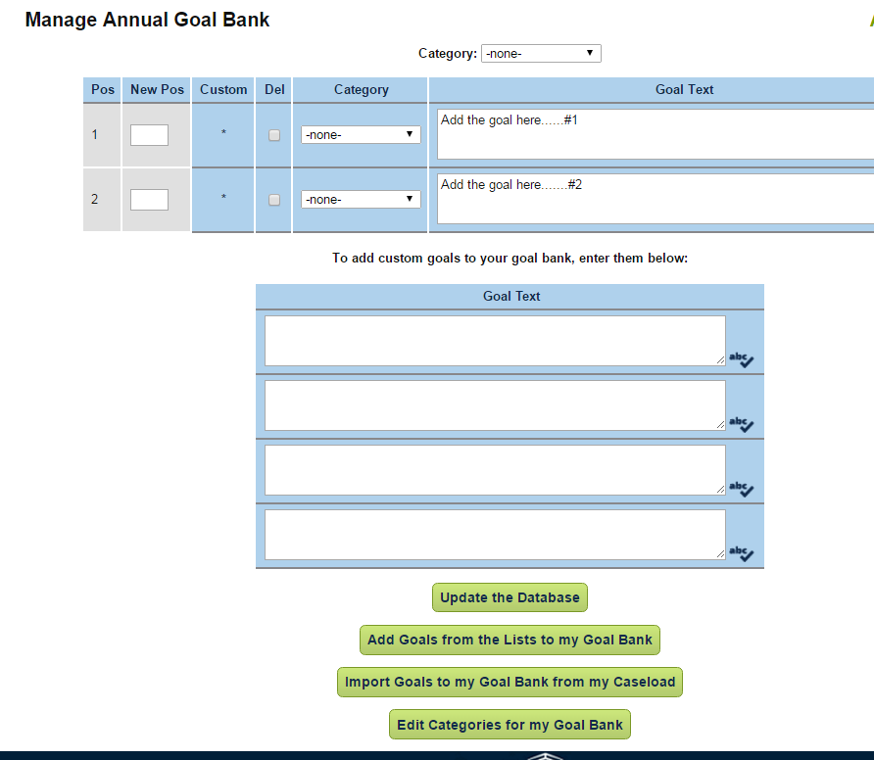

20. SETTING UP CATEGORIES.
a. Select Edit Categories for My Goal Bank.
b. A new window opens. In the snapshot below, categories have been created; however, new categories can be created. A user can position the categories, delete categories, as well as, view the number of goals in each category. Category names can be modified. As always, “Update the Database”.
Please note: If a user deletes a category, all the goals associated with that category are placed in the NONE category in the user’s bank.
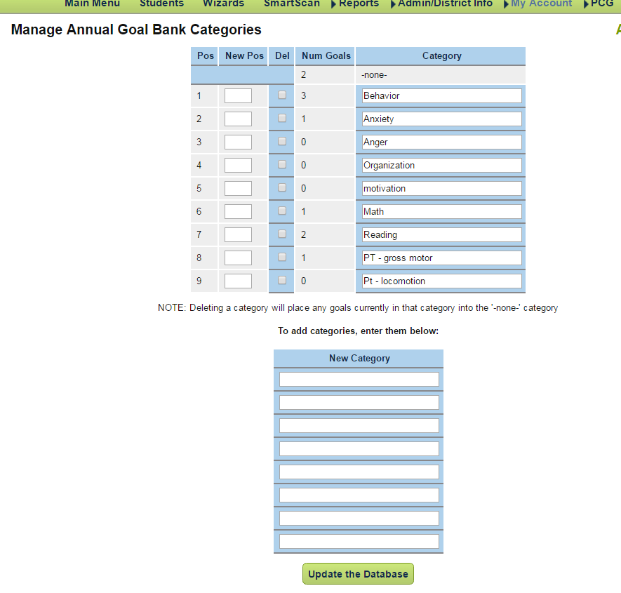

21. Develop an OBJECTIVES Bank using the same process.

