EdPlan/EasyIEP How To: Invitation
1. Log into EdPlan
2. Select Student from caseload
3. Go to Documents
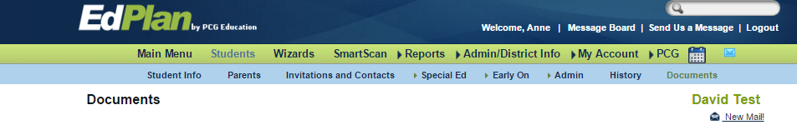
#3
4. Locate and select Invitation (4a). Create Final Document (4b).
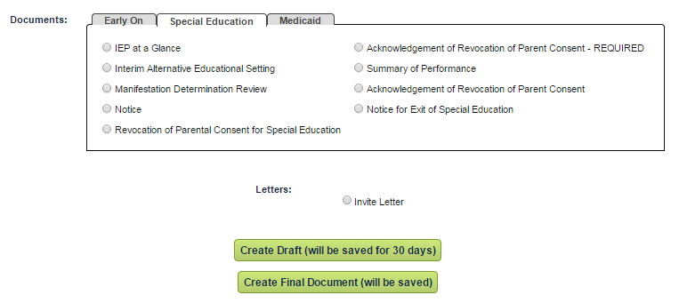
#4b
#4a
5. New window opens.
a. Select who will receive the invitation.
b. Select address for the student.
c. Add date of meeting, meeting time, purpose, location and address.
d. Select which team member will be included on the invite. Add team member role.
e. Add other representatives attending, if any.
f. Add who is sending the letter of invite.
g. Print return page, check yes. This will provide a response sheet for parents to RSVP to the meeting.
h. Select “Create Final Document”.
i. Invitation has been completed. Invitation will be stored in “Documents folder” and under tab “Invitations and Contacts”.

