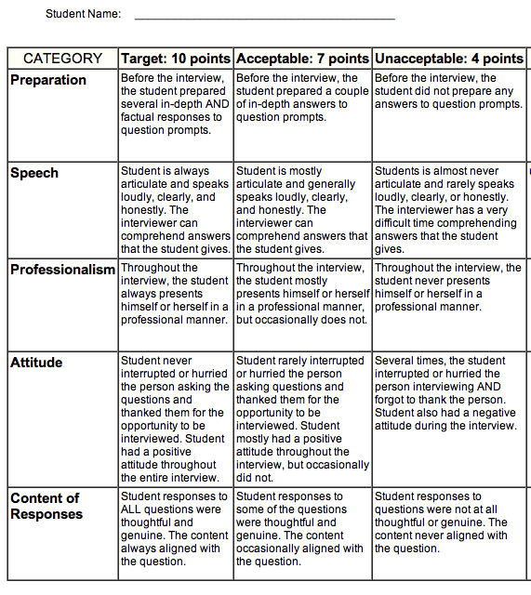

Total: ________________ / 50 points