Resume Rubric

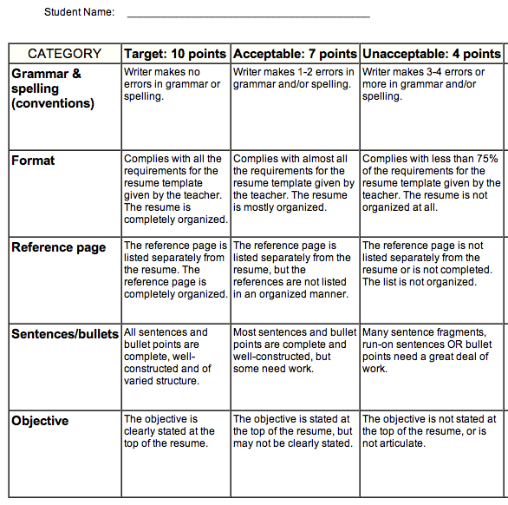

Total: ___________ / 50 Points

